INTERNATIONAL SYMPOSIUM ON REPRODUCTION IN AQAUTIC ANIMALS
(REPROAQUA-2024)
19-20 October 2024 TRABZON / TURKEY

Please note that you should pay the registration fee to the bank account (IBAN) and send with this symposıum registration form together to the reproaqua@gmail.com as soon as possible.
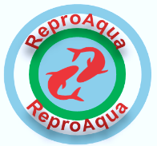
Signature :
Date:

SYMPOSIUM REGISTRATION FORM
PARTICIPATION TYPE *  Oral Presentation ( )  Poster Presentation ( )  Listener ( )  Accompanying ( ) | Title of the Presentation:
NAME - SURNAME
INSTITUTE
E-MAIL
CORRESPONDING ADRESS
PHONE
HOTEL
ACCOMMODATION DATES
ARRIVAL DATE TO
TRABZON
RETURN DATE
FROM TRABZON
GALA DINNER  19th October 2024, Saturday | □ PARTICIPATE
SOCIAL TOUR TO SUMELA  21th October 2024 Monday | □ PARTICIPATE
* Please mark your participation type

