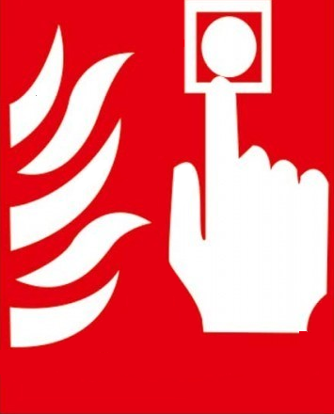

**ALARM BUTONU**



**ALARM BUTONU**

**ALARM BUTONU**

**ALARM BUTONU**